PART A – 95 points
Page limit for Part A: 2 (8.5 X 11) pages (font size at least 11 point) – graders will not consider any answers beyond the first 2 pages.

1. Glaucoma Screening (35 points)

The Affordable Care Medical Center administered a new screening test for glaucoma to 479 adults aged 50 years and older. Among these 479 adults, review of the electronic medical records indicated that 103 were known to have glaucoma. Among the 103 adults with glaucoma, 87 tested positive on the new screening test. Among the 376 adults who did not have glaucoma, 14 tested positive using the new screening test.

a) Complete the 2 x 2 table: (9 pts)

 | True Glaucoma Status
Screening test | Has Glaucoma | Does not have Glaucoma
Tested Positive
Tested Negative

b) Based on the data, calculate the new screening test’s sensitivity: (Give your answer as a % to one decimal place - 5 pts)

c) Based on the data, calculate the new screening test’s specificity: (Give your answer as a % to one decimal place - 5 pts)

d) Based on the data, calculate the new screening test’s positive predictive value: (Give your answer as a % to one decimal place - 5 pts)

e) Based on the data, calculate the new screening test’s negative predictive value: (Give your answer as a % to one decimal place - 5 pts)

f) Based on your answers, would you recommend that this new test be used to screen for glaucoma in general populations? Why or why not? (6 pts)

2. Collecting and using published works (60 points)
This assignment includes reviewing two “how to” videos on the http://ahsl.arizona.edu/COM-Phoenix
site. Each video is under 5 minutes in length. You will have to do steps you learn about in the videos, so be prepared to watch more than once, stop, take notes or do the step. This 60 point activity gives you brief experience in using RefWorks – software that helps in managing and using citations. While RefWorks is not the only citation software, it is freely available to you through the U of A and most of the other programs work quite similarly.

Steps:
1. Go to http://ahsl.arizona.edu/COM-Phoenix
2. Under the “Curricular Resources” list, you should see a “Scholarly Projects” heading
3. View the “Using RefWorks for your Scholarly Project – Beginning” video (4 minutes 43 seconds). Just select the triangle to start video.
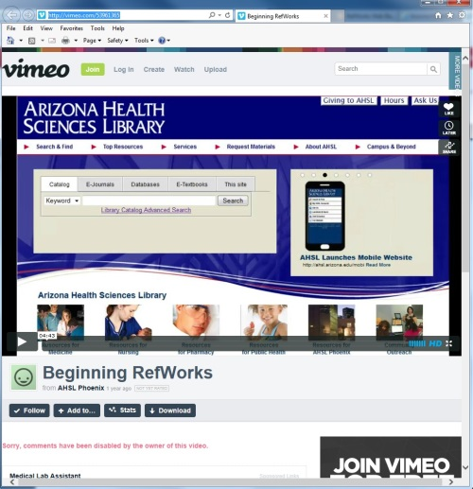

Keep in mind that you can pause the video as much as you want along the way to follow the steps (such as creating a RefWorks account)
5. By now you should have a RefWorks account. Open your RefWorks account. [As noted in the video, go to ahsl.arizona.edu, select “Top Resources” select “RefWorks & EndNote” or “RefWorks|EndNote|Mendeley” depending on how you do your selection, the select “Go to RefWorks” and sign in].
6. In the same way that Librarian Carlson completed a PubMed search, complete a search in PubMed using the following search phrase: airplanes and influenza
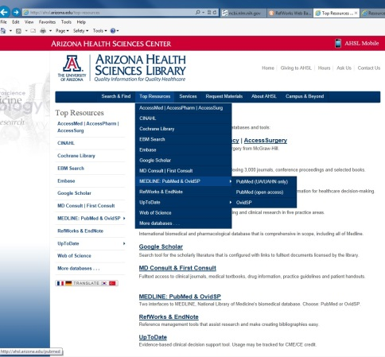
Top Resources → MEDLINE:PubMed & Ovid→PubMed (UA/UAHN)only→ airplanes and influenza
7. You should get 73 Results.
We only want those 6 articles:
(1) Mangili A, Vindenes T, Gendreau M.
(2) Sze-To GN, Yang Y, Kwan JK, Yu SC, Chao CY.
(3) Schwartz MD, Marcias-Moriarity LZ, Schelling J.
(4) Wagner BG, Coburn BJ, Blower S.
(5) Malone JD, Brigantic R, Muller GA, Gadqil A, Delp W, McMahon BH, Lee R, Kulesz J, Mihelic FM.
(6) Grais RF, Ellis JH, Kress A, Glass GE.
(these will likely be numbers 1,4, 10,38, 44, and 61). Select those six references by checking the box next to the title of each.
8. Save these six references into your RefWorks as demonstrated in the video. You will need to select “Display Settings”, select “MEDLINE”, apply, Ctrl-A and then Ctrl-C, to copy the five references into your RefWorks “Last Imported” folder.
9. As described in the video, save these reference into a new folder you create and name (i.e. Airlines and Flu). Make sure you have all six references. You can repeat the step as needed to collect the six references into your folder.

Second Video (4 minutes and 11 seconds)
10. Back on your http://ahsl.arizona.edu/COM-Phoenix page, watch the “Using RefWorks for your Scholarly Project-Advanced. One Line/Cite View”.

11. Using the abstracts of the six references* as your sources (if you select the magnifying glass of the reference when it is listed in your folder in RefWorks, you can view and read the entire abstract), write a brief answer (1 – 2 paragraphs), to the question, What should holiday travelers know about flu risk? Your brief summary must include correctly cited references (using the approach and format demonstrated in the 2nd video) and a correctly formatted Bibliography (after selecting “Create Bibliography”, you’ll need to select “Manage Output Styles” to be able to select the output style for: American Medical Association (10th edition). Use the green arrow to move the AMA style over to Favorites. Once you have AMA as an Output Style, on that same “Create a Bibliography” window, in small print near the bottom, select format a paper and bibliography and follow the directions on the next windows from a list of references). Please go ahead and single space your references.

Notes: There is also a Using RefWorks to Manage your Research.pdf document on the http://ahsl.arizona.edu/COM-Phoenix that you may find useful as a reference for the various steps.
Easy reference for AMA style can be found here: http://www.lib.jmu.edu/citation/amaguide.pdf

*No, I am not trying to encourage using abstracts instead of reading the full articles for your literature reviews. Outside of this singular assignment (which is aimed at the approach rather than the content), ALWAYS read the full paper and do not rely on the Abstract alone for results (you will find that “results & conclusions” can be “cherry-picked” or the study poorly designed to justify the “findings”). However, for this class what is important is stating a clear opinion and properly citing sources which provide some backing for your statement. Also, one aim of Basic Epidemiology is to prepare you to approach projects/research including summarizing and reporting results. By completing this part of your exam, you should be prepared to use software resources such as RefWorks (freely available to you through UA) and others (which are quite similar in how they work) when you are writing or critiquing papers in your field.

Example:
Example paper for Part A.2 Epi Exam 3 Fall 2015
Appropriate title that indicates position such as:
Students’ mastery of RefWorks is demonstrated in the A2 Summary
Oral and written communication is critical in public health. Regardless of the venue, appropriate credit of information sources is an important aspect in presenting information. RefWorks© is one tool that allows students to easily include the proper citation in the correct format while writing.¹ Or, students may need to include multiple citations at a time. ²⁻⁴ For successful completion of the Epi Exam 3 test paper, students will need to use all five citations in their brief written summary.⁴ Students must make sure that a position is selected (do you believe there is evidence that soda consumption is associated with weight gain, or not) and this position is clearly stated in the summary.

References
1. Byrne CE, Fitzgerald A, Cannon CP, Fitzgerald DJ, Shields DC. Using the Refworks resource for citations. Bogus Med J. 2004;5:13-2350-5-13.
2. Fontes JD, Yamamoto JF, Larson MG, et al. Many references: Solidifying the written position. Written Articles 2013;228(1):217-223.
3. Guzman-Guzman IP, Munoz-Valle JF, Flores-Alfaro E, Salgado-Goytia L, Salgado-Bernabe AB, Parra-Rojas I. Including citations that indicate risk factors. J Markers. 2010;28(1):29-36.
4. Cheng S, Lyass A, Massaro JM, O'Connor GT, Keaney JF, Vasan RS. References that support a position. Education. 2010;122(15):1470-1477.

Point breakdown:
20 pts: Summary – stating an answer to the question and backing up your answer with citations, What should holiday travelers know about flu risk?
20 pts: Inclusion of all six references within the written summary, in the appropriate finished format.
20 pts: Bibliography – appropriately formatted for American Medical Journal

PART B – 80 points
Page limit for Part B: 3 (8.5 X 11) pages (font size at least 11 point) – graders will not consider any answers beyond the first 3 pages.

At the beginning of the semester you read a newspaper article discussing the potential role of soda consumption in the American obesity epidemic. Many of you were quite skeptical of the reported findings. Now you have a chance to examine the association for yourself (and contribute to the literature).

Scenario I: (40 points)
You are given sufficient funding to complete a case-control study of 100 individuals examining the association of obesity and soda consumption. You select 50 individuals aged 25 to 35 years that are normal weight (BMI category of 19 – 25) and 50 individuals who are obese (BMI > 30 and <40). You know that obesity does not happen over night so you decide it is important to ask your study population of 25 to 35 year olds to tell you about their soda intake while they were in their teens (10 up to 20 years of age). For your initial analysis, you divide up the self-reported soda consumption data into two groups: high (3 or more 12 oz sodas daily) and low (less than 36 oz soda per day) intake. Twenty of your normal weight participants report low soda intake in their teens. Fifteen of your obese participants report low soda intake. Respond to the following questions:

1. State your research question. (2 points)

2. Set up (draw out) your 2 by 2 table of your study. Be sure to include all appropriate labels and numbers (13 pts)

3. Using the appropriate effect measure for this study design, how does the risk of obesity differ by soda consumption? Show your calculation and give your answer to two decimal places. (10 points)

4. Interpret your measure of association (findings). (5 points)

5. What are the strengths of your case-control study? (5 points)

6. What are the weaknesses of your case-control study? (5 points)

Scenario II: (40 points)
You are given sufficient funding to develop a cohort study examining the association of obesity and soda consumption. You want to develop the best cohort study you can with the funded opportunity you’ve been provided. You realize that there are many studies that have routinely surveyed nationally-representative groups of the American population along with many large U.S. cohort studies. Most of these studies will provide access to data to investigate important questions (Examples: NHIS, NHANES, Framingham Health study, American Cancer Society cohorts, California Teachers Study, Multiethnic cohort study, Physician’s Health Study, Nurses’ Health Study, Women’s Health Initiative, etc) so you choose to use one of these established cohorts. If you have not reviewed Module 48b regarding Cohorts, please complete this review prior to attempting this section.

I would recommend that you look up details (baseline paper or reference that describes that cohort) to make sure the cohort you select has the population and information you need.

Respond to the following questions:

1. State your research question. (2 points) Please note: A research question must be test-able!

2a. What cohort did you select? (2 points)
2b. What attributes did you consider in selecting that cohort (your population source)?
(hint: what is important to know about your participants, what factors need to be included. Etc.) (6 points)

3. What would be your inclusion criteria? (In other words, who is your participant population? Be specific. (5 points)

4. What would be your exclusion criteria? Be specific. (5 points)

5. What confounders do you want to potentially include in your analyses and why? (5 points)

6. What bias might be concerning? Why? (in other words, if you don’t account for this bias, how may it affect your results?)- select one very important potential bias only but make sure you describe it well (5 points)

7. What are the strengths of your cohort study? (5 points)

8. What are the weaknesses of your cohort study? (5 points)

Please remember to include your Lastname Exam3 in the header and as your file name when you submit your Exam 3 into the dropbox. Please remember to adhere to all page length maximums including font size and margins.

